10.90: Angular momentum is conserved, so 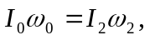 or, using the fact that for a common mass the moment of inertia is proportional to the square of the radius, 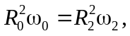or
where the terms in 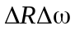 and 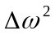 have been omitted. Canceling the 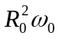 term gives
